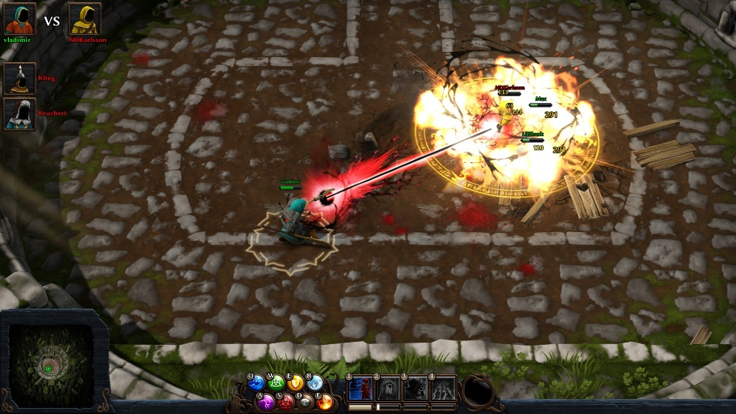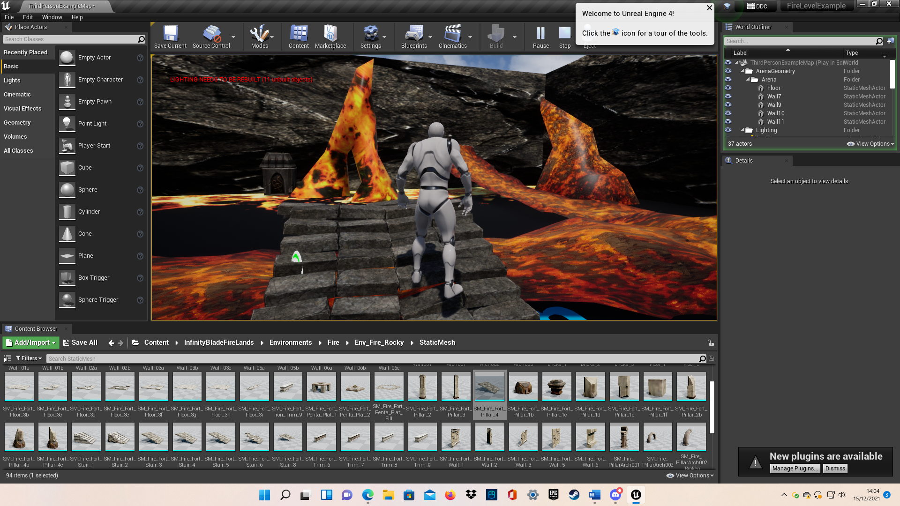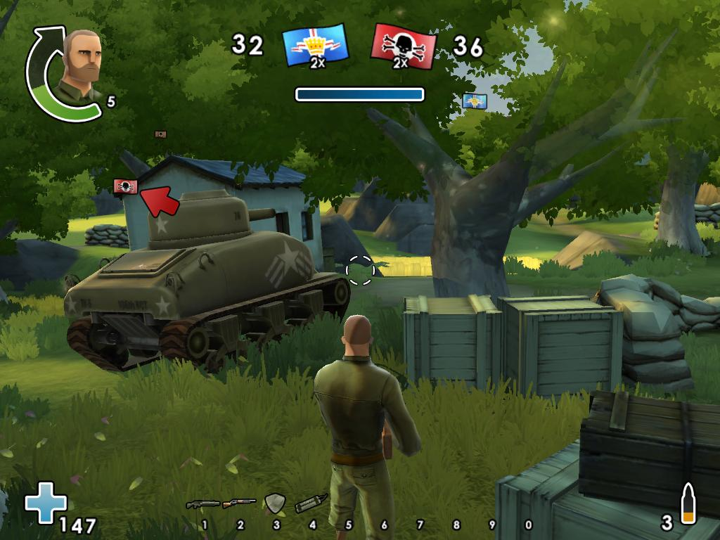

Another sound collection I’ve used a lot, I think this is perfect for our game because of the wizard theme, there are some light themes that could be menu music and then some harder ones that’d be perfect for combat or to create a sense of unease while keeping the fantasy aesthetic

I’ve used this for a few projects this is an easy way to get general player sounds, like grunts or screams when they get injured, death sounds and grunts when they attack, there’s male and female voices depending on what gender you want the character

This is just an example of what I thought the power use should look like in general, I didn’t get too many examples because I think each power should look different

This set gave is the exact look I had in my head, it

has a lot of flowing lava rivers, lava waterfalls

(Lavafalls?), rocks and lots of textures that can be

added to other meshes we make to fit in the

environment, you can’t see in the picture, but the

lava is flowing, they have animations.

This set didn’t really give me the look I imagined for the water level, I’m including it more for the water meshes and textures and pre done waterfall, I figured with a tight time frame anything like this is a win so we can focus on other things we need to make ourselves

This is the look of the game I had in my head, I’d call it Fortnite cartoon style, I thought it’d look best and have the best chance of packs in the unreal marketplace blending in, my only thought is will the water look to realistic for this style to fit?